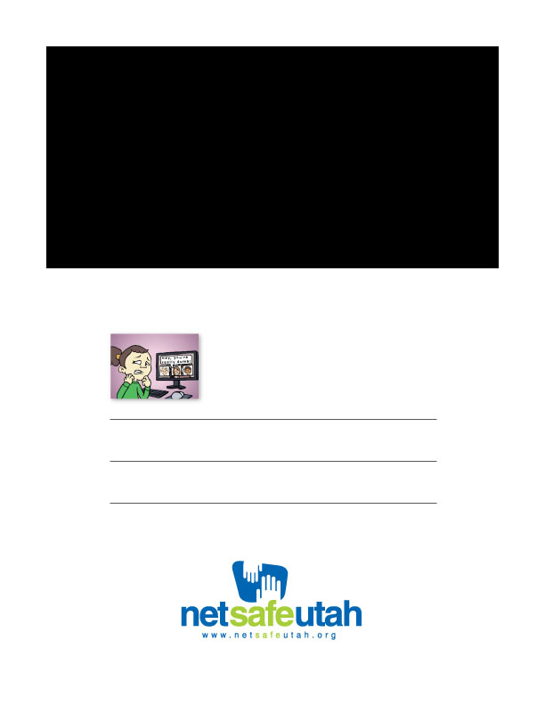

[Date, time]

[School Name]

# [Enter text here for advertising an event (e.g., Are your kids safe from bullies?)]

Learn how to keep your kids safer from bullies and other threats, online and in person. Attend our internet safety presentation for parents: