 | Internet Safety For  4-6 Grades

Cyber-bullies are No Fun  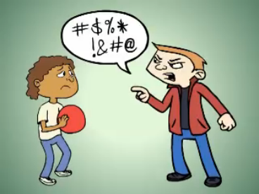 | What is cyber-bullying?  - People who send mean text messages, e-mails or taunt kids on web sites are called cyber-bullies  - Cyber-bullying can happen anywhere even when you think your are safe at home  What should you do if someone cyber-bullies you?  - Do not respond to the cyber-bully and save the nasty e-mails, the web site postings, and the text messages then report them to your parents, teacher, or other trusted adult

What is personal information?  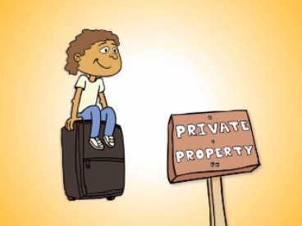 | What is personal information?  - It is anything that identifies where you live and who you are such as your name, address, e-mail, and phone #, pictures of you and your family and friends, and passwords – it is like a suitcase that we carry around with us and we use it everyday  How can you keep your personal information safe?  - Keep your personal information private and only give it out to people you know and trust  - If you are unsure about whether you should unlock your Internet suitcase, talk with your parents or another adult you trust  - Keeping your personal information safe helps you and other around you to stay safe

Online Friends  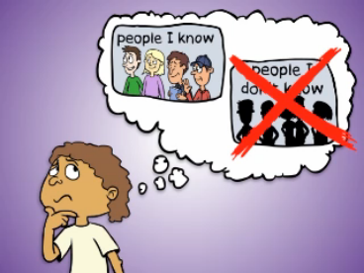 | How should you decide who to be friends with online?  - If you are friends with someone in the real world, it is okay to be friends with them online  - This goes for all kinds of web sites, chat rooms, e-mail, text messaging, and instant messaging  - Stick to what’s real – real friends in the real world

Posting Pictures Online  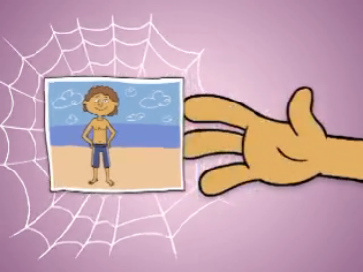 | What can happen if you post a picture online?  - A picture posted to a web site can be copied and pasted to other web sites  - Once a picture is out on the web there is no way for you to get those photos back  - Pictures can show where you live, go to school, and other personal information  - Pictures that show kids without any clothes on (having or sharing them) are against the law  - Posting a picture can only take a second but can last a lifetime

Talk to an Adult You Trust  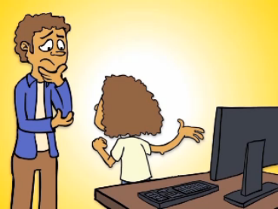 | Who are people you trust?  - They could be your mom & Dad, your guardian, your brother or sister, your teacher, a police officer, your grandparents, or your aunt or uncle  What should you do if something you experience on the Internet or in the real world makes you feel uncomfortable, sad, or scared?  - Tell a trusted adult – they can help you feel better  What should you do if someone you trust does something that makes you feel uncomfortable?  - Talk to another adult that you trust about it

For more information on Internet safety or to view and download these videos,
go to: http://www.netsafeutah.org

