 | Internet Safety For  K-3 Grades

What is the Internet?  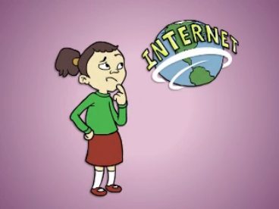 | How big is the Internet and is it part of the real world?  The Internet is very big and it is not part of the real world.  What are the good things on the Internet?  Online games, music, and videos are some of the good things on the Internet.  Is the Internet made just for kids?  No. There are parts of the Internet that are not for kids.

What is personal information?  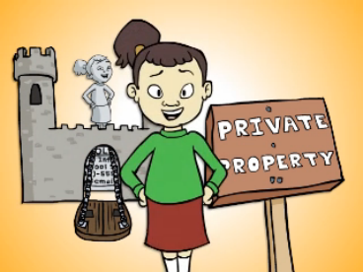 | What is it?  - It is anything that identifies where you live and who you are. For example, your name, address, e-mail, and phone number.  How can you keep your personal information safe?  - Think of it as living inside a big castle that no one can get into unless you let them.  - Guard your personal information from people that you don’t know, but you can give it out to people you know and trust.

Online Friends  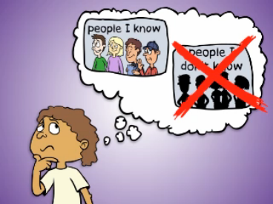 | How should you decide who to be friends with online?  - If you are friends with someone in the real world, it is okay to be friends with them online  - This goes for all kinds of web sites, chat rooms, e-mail, text messaging, and instant messaging  - Stick to what’s real – real friends in the real world

Tell to an adult you trust  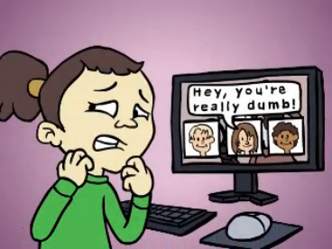 | Who are people you trust?  - They could be your mom & Dad, your guardian, your brother or sister, your teacher, a police officer, your grandparents, or your aunt or uncle  What should you do if something you experience on the Internet or in the real world makes you feel uncomfortable, sad, or scared?  - Tell a trusted adult – they can help you feel better  What should you do if someone you trust does something that makes you feel uncomfortable?  - Talk to another adult that you trust about it

Be Kind Online  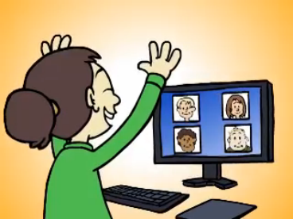 | What is the golden rule?  - Treat other people like you would want to be treated  What is important about being kind online?  - Good manners and kindness is just as important on the Internet as it is in the real world  - Choose to be kind and respectful and not like a green icky monster  - Being helpful and kind is the best way to make the Internet safe and fun for everyone

Cyber-bullies are No Fun  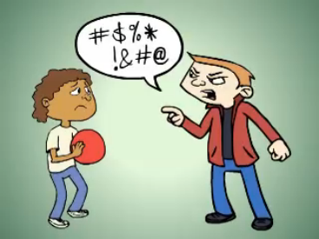 | What is cyber-bullying?  - People who send mean text messages, e-mails or taunt kids on web sites are called cyber-bullies  - Cyber-bullying can happen anywhere even when you think your are safe at home  What should you do if someone cyber-bullies you?  - Do not respond to the cyber-bully and save the nasty e-mails, the web site postings, and the text messages then report them to your parents, teacher, or other trusted adult

For more information on Internet safety or to view and download these videos,
go to: http://www.netsafeutah.org

